***PROGRAMMING DUNDAMENTAL LAB 1 TASK***

Task 1:

|  |  |
| --- | --- |
| GIVEN DATA | OUTPUT REQUIRED |
| * The school bell is scheduled to ring at 1:00 PM. * Today, it did not ring. | * Is there electricity at the time? * Is the bell in working condition? * Was the timer set properly? * Was there any manual override? * Has this issue happened before? |
| PROCESSING REQUIRED | ALTERNATE SOLUTION |
| * Power supply failure. * Bell system malfunction. * Timer not set correctly. * Human error (operator forgot). * Wiring or technical issue. | * Check power supply. * Inspect bell hardware. * Verify timer settings. * Ask responsible staff if they checked. * Repair or replace faulty parts. |

Task 2:

|  |  |
| --- | --- |
| Given Data | Output Required |
| * Length * Width | * Area of rectangle |
| Processing Required | Solution Alternative |
| * Area= Length* Width | * Define the input as constant * Define data as input values |

Task 3:

|  |
| --- |
| 1. Start   Start   1. Turn 15 degrees to right 2. Wait for one second   Turn 15 degrees to right   1. Turn 15 degrees to right 2. Wait for one second 3. Stop   Wait for one second      Stop  Wait for one second  Turn 15 degrees to left  Start |

Task 4:

|  |
| --- |
| 1. Start   Start   1. Input the Celsius from user,C 2. Fahrenheit= (C*9/5) +32   Input the Celsius from user,C   1. Print Fahrenheit 2. Stop   Fahrenheit= (C*9/5) +32  Print Fahrenheit  Stop |

Task 5:

1. Start
2. Input the first number
3. Input the operator (+, -, *, /)
4. Input the second number
5. If operator is +, add the numbers
6. If operator is -, subtract the numbers
7. If operator is *, multiply the numbers
8. If operator is /, divide the numbers (if second number ≠ 0)
9. Display the result

10.End

Task 6:

1. Start
2. Input name
3. Print Hello name!
4. Stop

Task 7:

1. Start
2. Input marks of three subject, Math, Eng, Urdu
3. Total=Math +Eng +Urdu
4. Percentage=Total/300*100
5. Print Total
6. Print Percentage
7. Stop

Task 8:

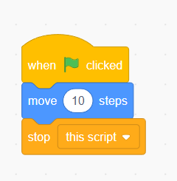

Task 9:

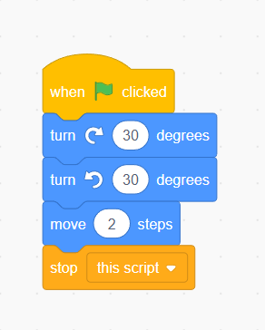

Task 10:

